Hotel Ashoka Palace is happy to welcome you!
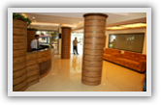
One of the finest retreats in the beautiful picturesque haven of Daman calmly resting by the side of the Arabian Sea. Come alone or bring your family with you, stay here for a night or for weeks, stay here while on business trip or at some kind of conference - either way our hotel is the best possible variant.
Feel free to contact us anytime in case you have any questions or concerns.

Facilities :
- Open Air Restaurant ( Serving India, Chinese, Continental and Gujarati Cuisine)
- Sea View Deluxe VIP Room
- Spacious well furnished Rooms with Bath Tub with Rain Shower & Hot & Cold Water
- Room Service facility
- Parking with 24hrs Security
- ATM at Doorstep
- Intercom
- Sweet Memories

Tariff Card:
- Sea View A/C Deluxe(VIP):Rs.5000/-
- Sea View A/C Deluxe: Rs.2500/-
- Extra Person / Mattress : Rs. 500/-

- Children Above 6yrs Chargeable
- Govt. Tax@ 8.57%

- CHECK OUT TIME : 11:00 AM

A Multi Cuisine Restaurant
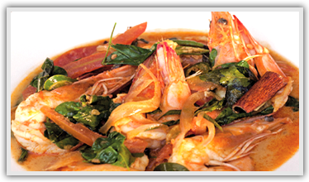

Nice and tasty!
- Serving Indian, Chinese, Continental and Tandoori.
- Made from French ingredients!
- Cooked by Master chef!
- Our restaurant provides you the ideal ambience to relax and enjoy your breakfast, lunch and dinner
- Proved to be good for your health!

Location
- We are located Opp. Devka Beach Park.
- Devka Beach, Daman 396210
- Ph: 0260-3244993

